Exercise 3-3 Variational Autoencoder

Jirayu Petchhan, D10907801

**Default given VAE model (latent dimension is 20.)**

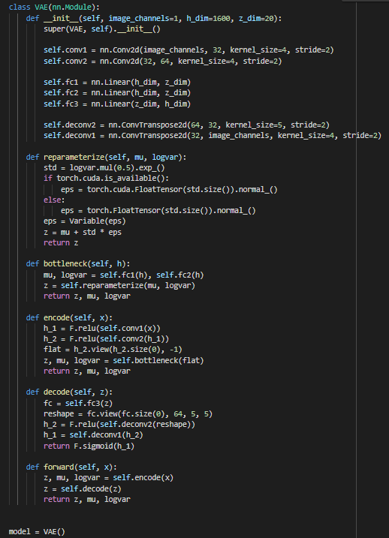

Cost function and optimizer selected

two loss function i.e. Binary-Cross Entropy and Kullback-Leibler Divergence.

Optimizer is Adam.

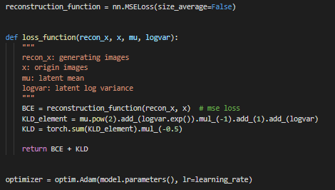

Set up training phase and training process start

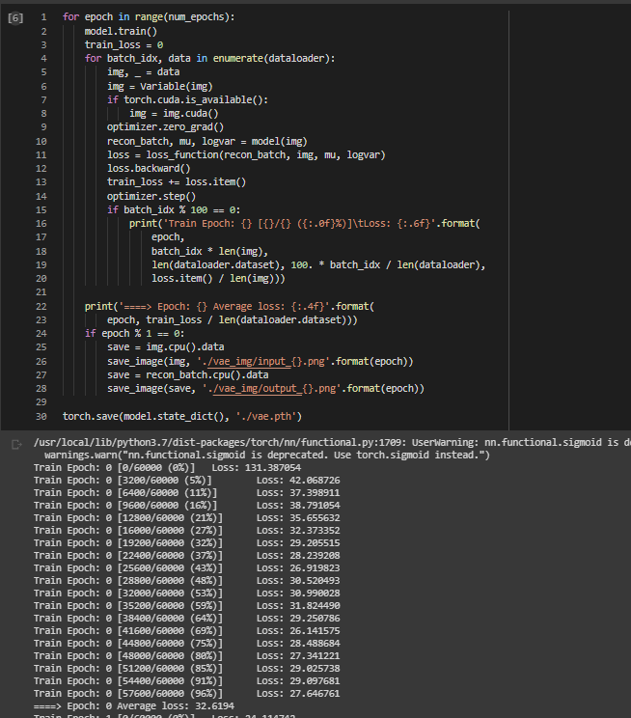

Training result at the final (avg. loss is about 25.90 %)

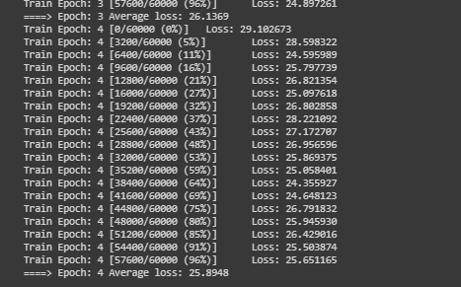

The result of generated image from 20 existing latent dimension (epoch=4)

|  |  |
| --- | --- |
| Input | C:\Users\e_user\Downloads\z_dim20\Input.png |
| Output (z\_dim = 20) | C:\Users\e_user\Downloads\z_dim20\Output_z20.png |

**VAE model (latent dimension is 10.)**

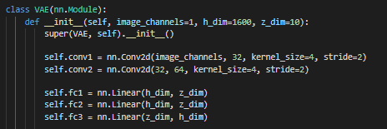

Training result at the final of z\_dim = 10 (avg. loss is about 25.7153 %)

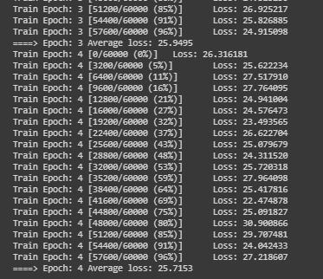

The result of generated image from 10 existing latent dimension (epoch=4)

|  |  |
| --- | --- |
| Input | C:\Users\e_user\Downloads\z_dim10\input.png |
| Output (z\_dim = 10) | C:\Users\e_user\Downloads\z_dim10\output_z10.png |

**VAE model (latent dimension is 1.)**

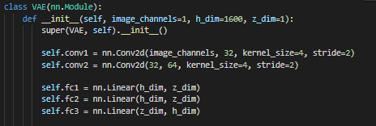

Training result at the final of z\_dim = 1 (avg. loss is about 39.1263 %)

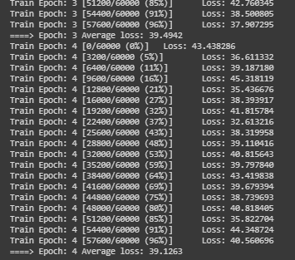

The result of generated image from only one latent dimension (epoch=4)

|  |  |
| --- | --- |
| Input | C:\Users\e_user\Downloads\z_dim1\input.png |
| Output (z\_dim = 1) | C:\Users\e_user\Downloads\z_dim1\output_z1.png |

**VAE model (latent dimension is 100.)**

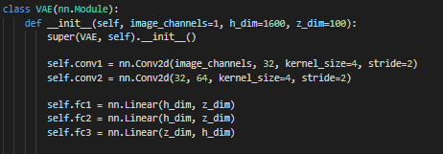

Training result at the final of z\_dim = 100 (avg. loss is about 26.2856 %)

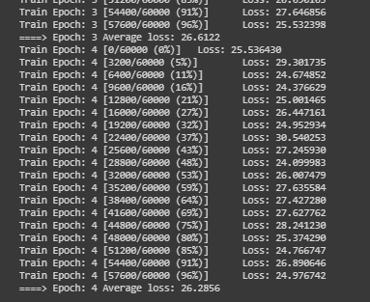

The result of generated image from 100 existing latent dimension (epoch=4)

|  |  |
| --- | --- |
| Input | C:\Users\e_user\Downloads\z_dim100\input.png |
| Output (z\_dim = 100) | C:\Users\e_user\Downloads\z_dim100\input.png |

**Conclusion**

We will see that when we add amount of latent space dimension more and more that effects the ability of the recognition from encoding to keep into more latent space. And if a lot of latent space that able to implement the latent representation in latent space to generate image that is similar as the real input image as possible.